English Vocabulary – Sale / Offer / Discount / Off


Sale:
On sale
Big sale
Super sale
Summer sale
Sale of the century
Sale on now
Up to half-price sale
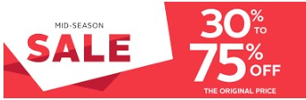
Flash sale
Mid-season sale
End of season sale
Clearance sale
Closing down sale

Offer:
Special offer

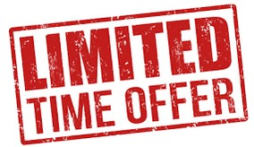
Best offer
Offer of the week
Great offer
Unmissable offer
An offer you can’t miss
Don’t miss out on this offer
Irresistible offers
Early bird offer
Exclusive offer
Limited time offer

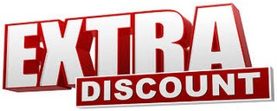
Discount:
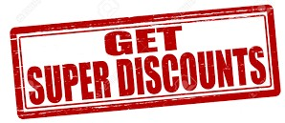
Special discount
Extra discount
Super discount
Fantastic discounts
Amazing discounts
Many discounted items
Discount on many items
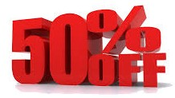
Off:
30% off everything – today only
Up to 70% off
50% off selected items
Up to 50% off (selected lines only)

Free:
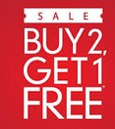
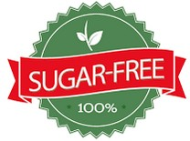
Buy 1 get 1 free
Buy 2 get 1 free
Free gift with every purchase

Also:
Gluten-free
Sugar-free
Lactose-free

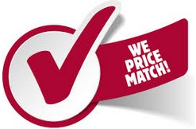

Price:
Everything half-price today
We match any price
One price only
Best price guarantee
Price match promise
We’ll beat any price by 10%

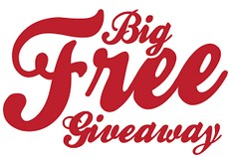

Giveaway:
A great giveaway
What a giveaway
The great summer giveaway
It’s giveaway time
Big free giveaway

Deal:
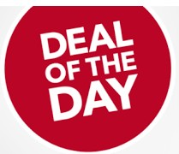

Big deal
Best deal
Great deal
Deal of the day
Don’t miss out on this deal
What a deal
Hot deals
Deal of the century
Biggest deal
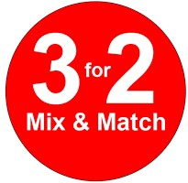

Other:
3 for 2
2 for 1
Save up to 50%
Further reductions

Note 1. The words “For sale” are not included in the lists above, as they simply mean “This is available for purchase” (PT: Vende-se).

Note 2. The word “Promotion” is a false cognate – it doesn’t mean “Sale” or “Offer”; it’s only used in two contexts:

1. When somebody gets a better position at work:
- John received a promotion yesterday. He is now a manager.
- I’ve worked here for 12 years, so I’m expecting a promotion soon.

2. For publicity of a product, organization, or event to increase sales or public awareness
(PT: divulgação, publicitário):
- We need to create an advertising campaign as a promotion for our new products.
- Do you have any promotion ideas to increase our sales?

